The Shear Tool

Contents

What is the Shear Tool? 1

How to use this Shear Tool 1

Extra Mesh Objects 7

To Sphere Tool 9

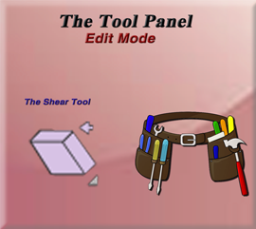

# What is the Shear Tool?

The Shear Tool is actually a very simple tool, that can be extremely helpful while modeling. That is because is will take a flat face and simply tilt it. Now when you extrude, you are no longer going straight out, but instead moving in the direction, which you are able to set for it. This can be amazing, especially when it comes to the intricate twists and turns that you will be trying to work with, while constructing a few pipes.



# How to use this Shear Tool

Let’s start out by getting rid of the default cube, and instead adding cylinder. This way we can demonstrate this usefulness while building a piping system in 3D. Go into Edit mode, and then select the top face of this cylinder.

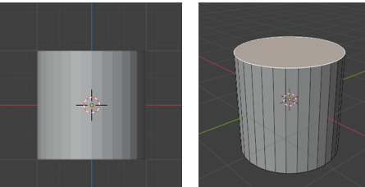

Go into Right Orthographic view. Number 3 on the numpad.

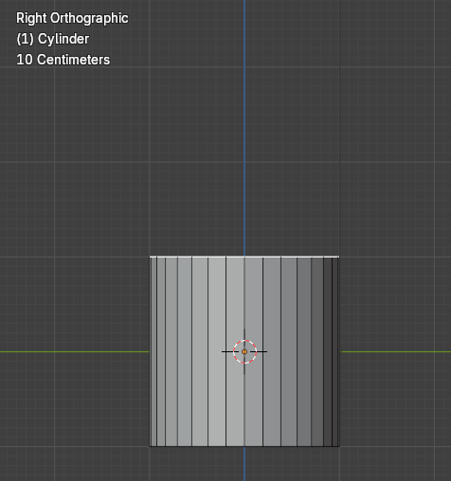

Now grab the Shear tool from the tool box.



You will notice these strange, colored rectangular knobs on the Shear gizmo in the viewport

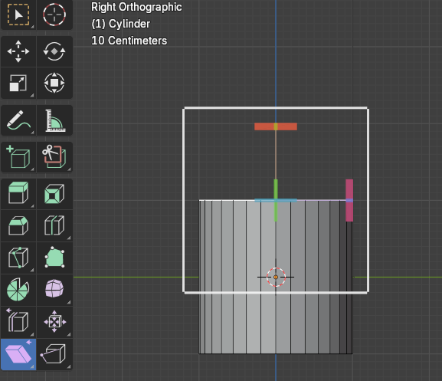

Each of those colored knobs, will represent a different axis, in which you can move the face around to achieve the look you want. If you move the red top knob at the top, it really won’t do anything.

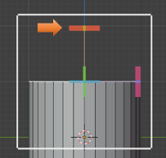

If you move the front green knob, it will twist the cylinder around, like this.

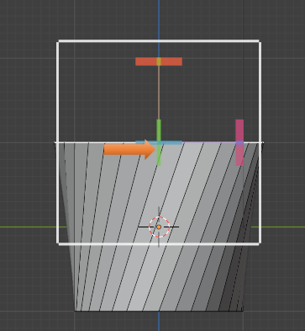

It is actually the red knob, at the right that we want to work with to make the object shear correctly. We can undo that twist by using the ctrl-Z and then try moving the maroon stick instead.

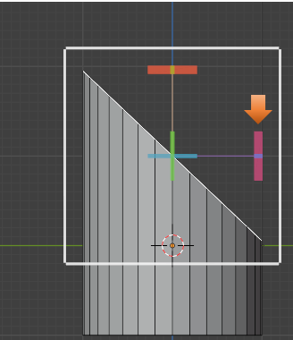

We can control the amount of tilt by using the Last operation dialog box at the bottom of the page. Move the Offset amount to change this tilt.

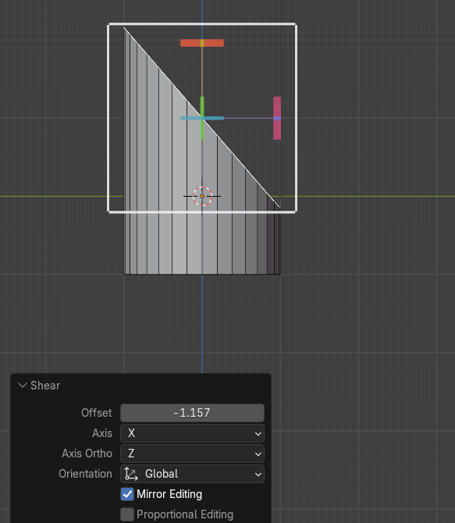

Notice that using the tool has elongated that top face just a bit

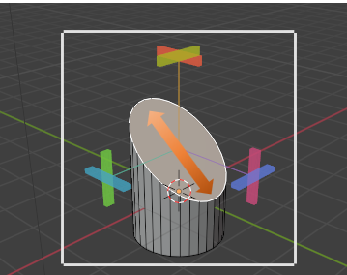

Now when you select that top face, and hit the E key we can extrude the shape off into the direction that is now set.

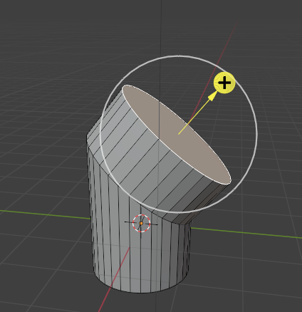

Shear it again

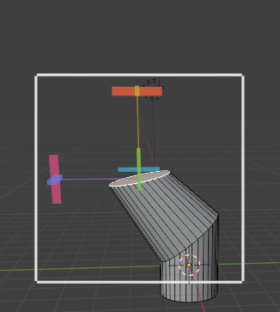

And Extrude it again

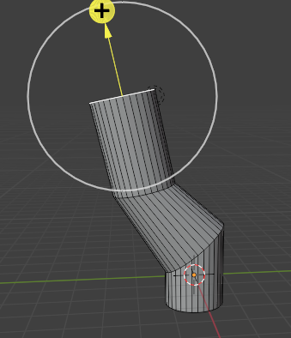

You can try and get a bit of a more uniform shape by using the scale tool. Alt-select that edge to select entire loop, and scale it down a bit.

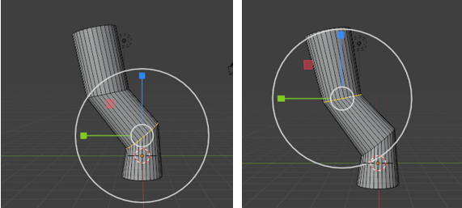

# Extra Mesh Objects

If you had added the extra mesh objects to the Blender program, you may have an easier time of creating these pipes then just using this tool and trying to build things from scratch.

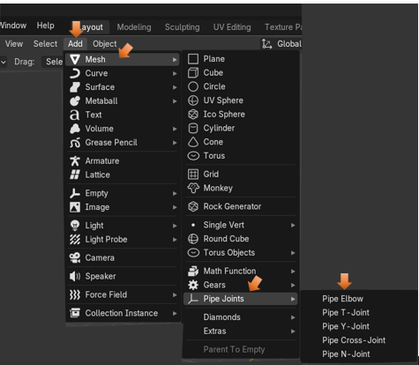

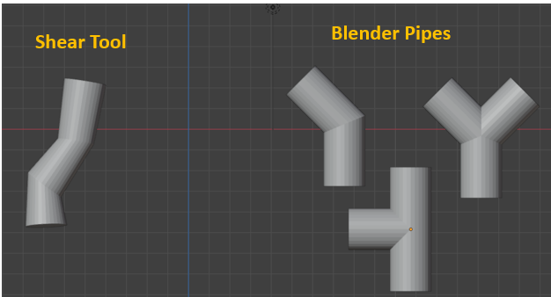

# To Sphere Tool

All this tool does is to try and take something and turn it into a sphere.

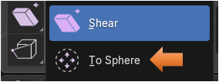

We can bring our cube into Edit mode, except that if we try to use it on a simple cube, it will do nothing, and that is because to create a sphere takes more than what the default cube is willing to give.

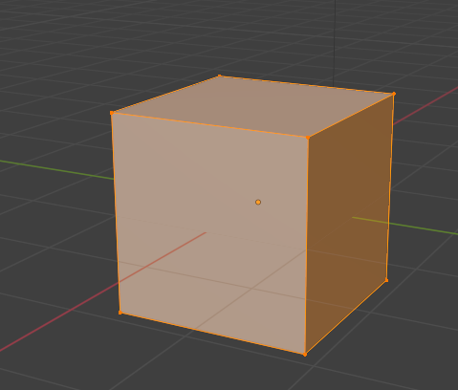

We need to Sub divide this cube to give it more geometry. Right click to reach the sub divide menu.

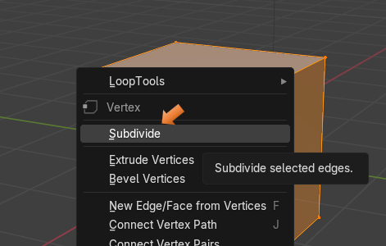

Bring the sub divisions up to 10

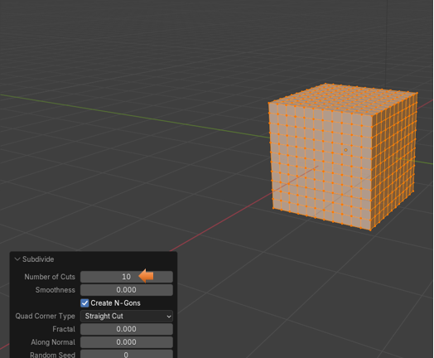

Now we can grab the To Sphere tool, and it will actually do something.



Drag the Factor Slider all of the way to 1.000, and you turn a cube into a perfect sphere.

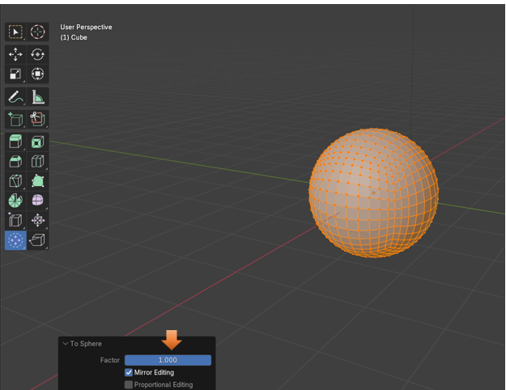

You will find this tool will not work on everything. This is a cylinder, and we needed to set the Cap Fill Type to Triangle fan, if we even wanted to get this.

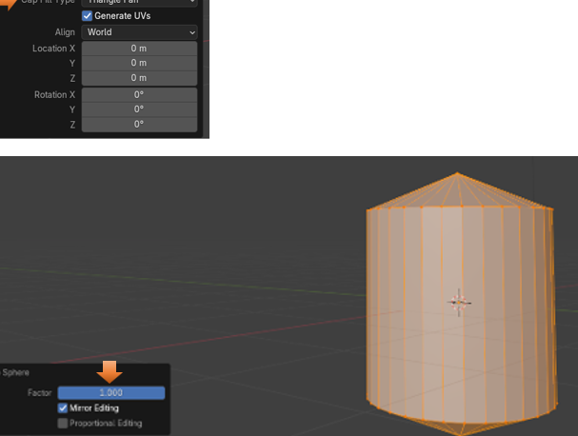

Well, that is all there is to it for this tool. You may find it helpful or not for your own 3D modeling needs.